











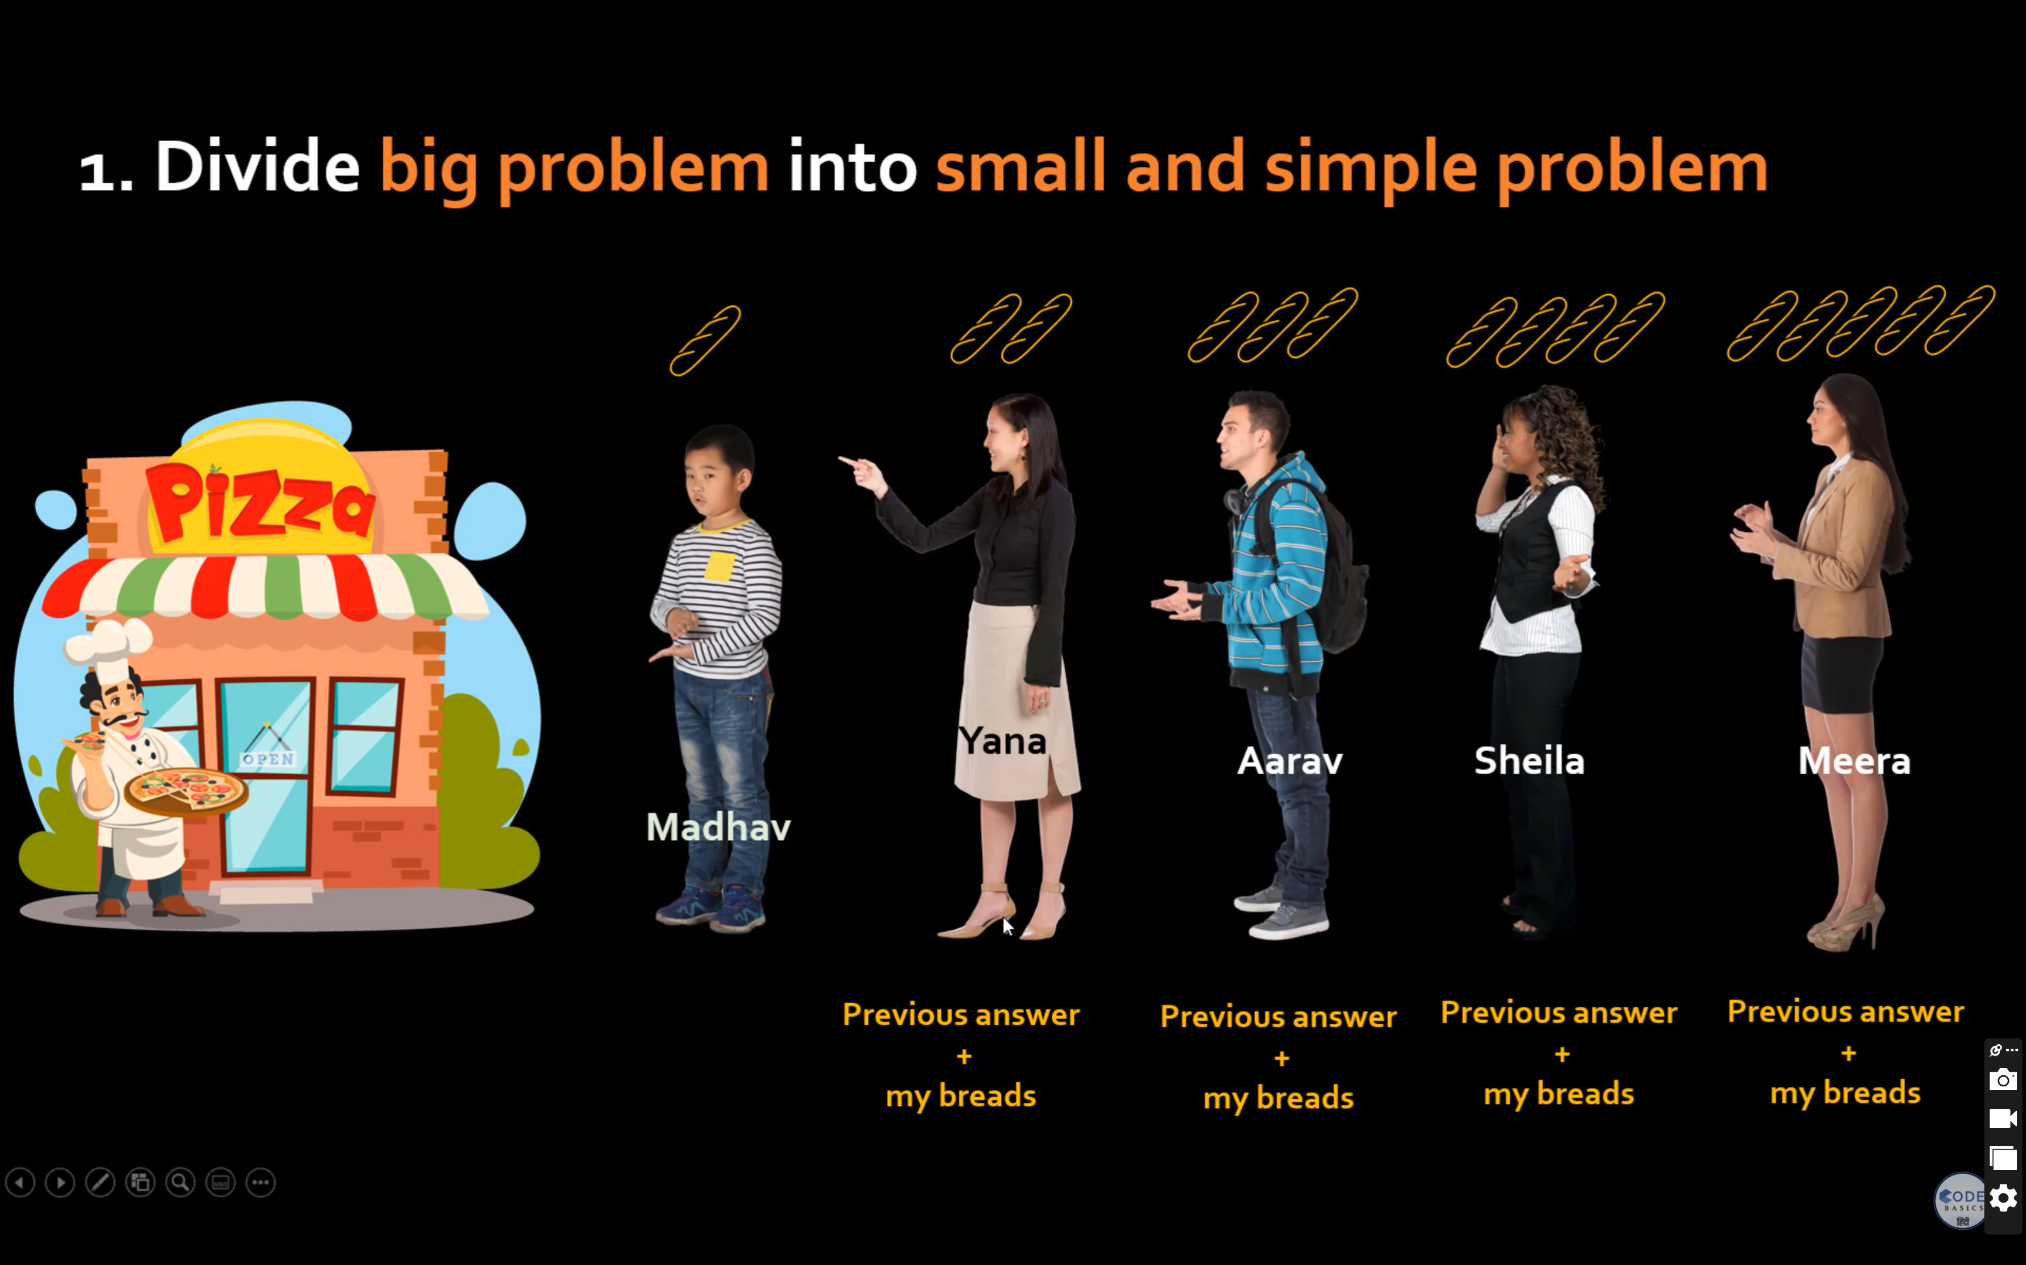



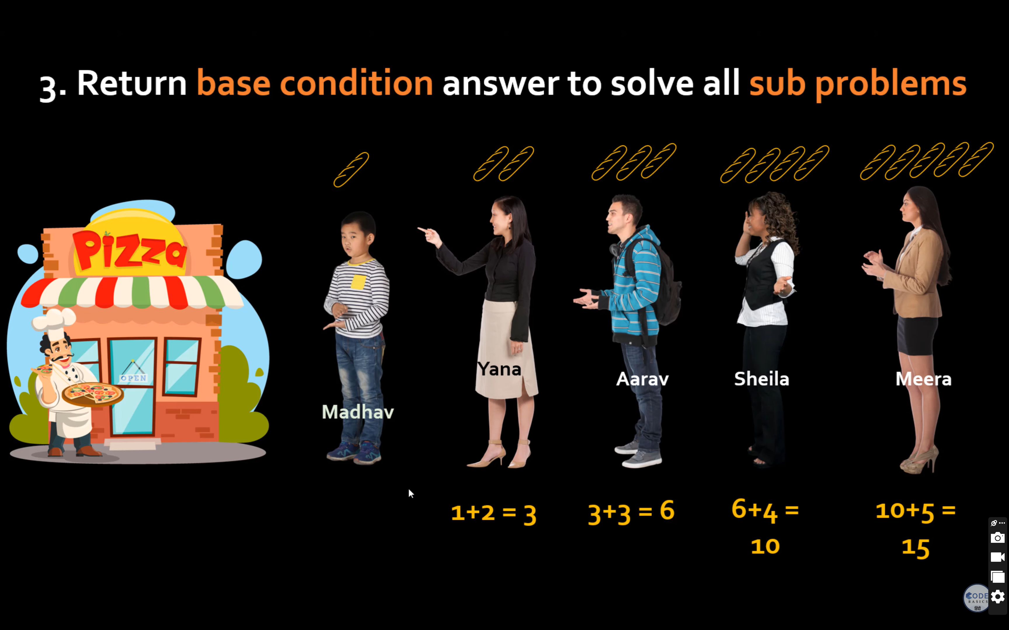

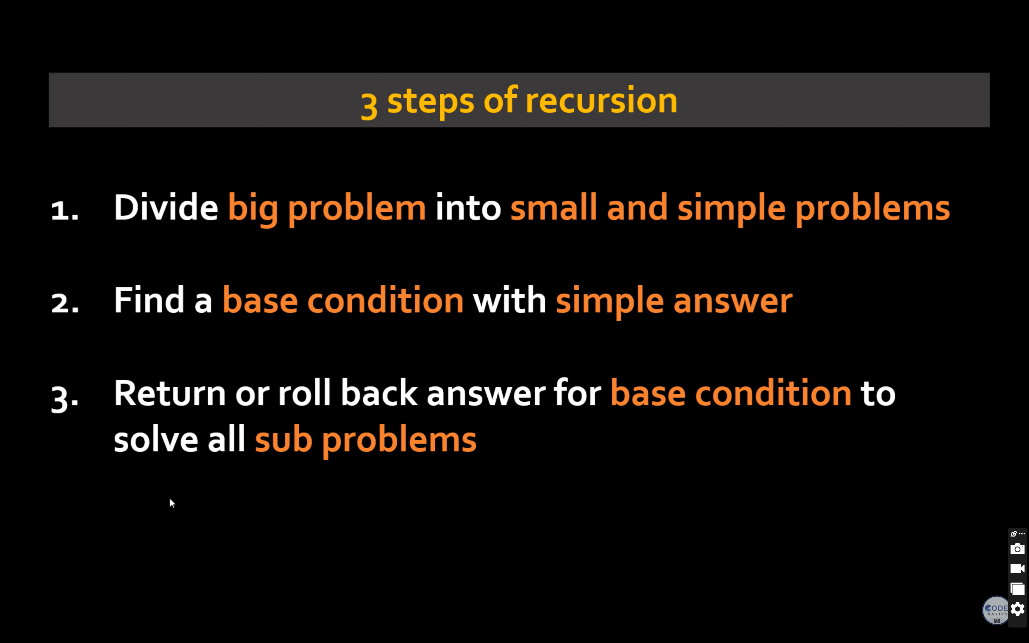

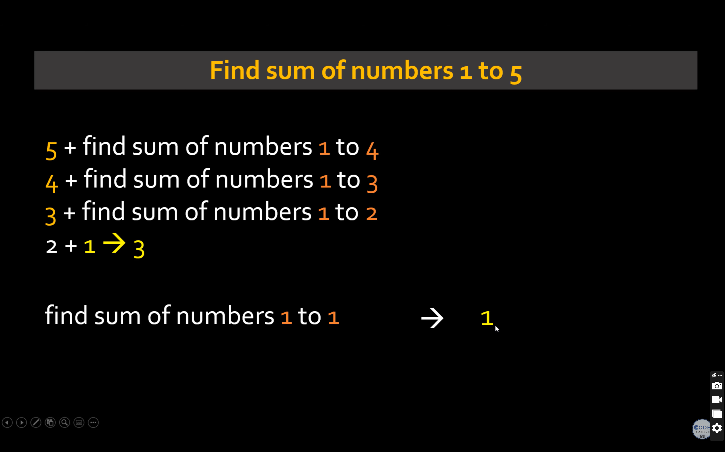

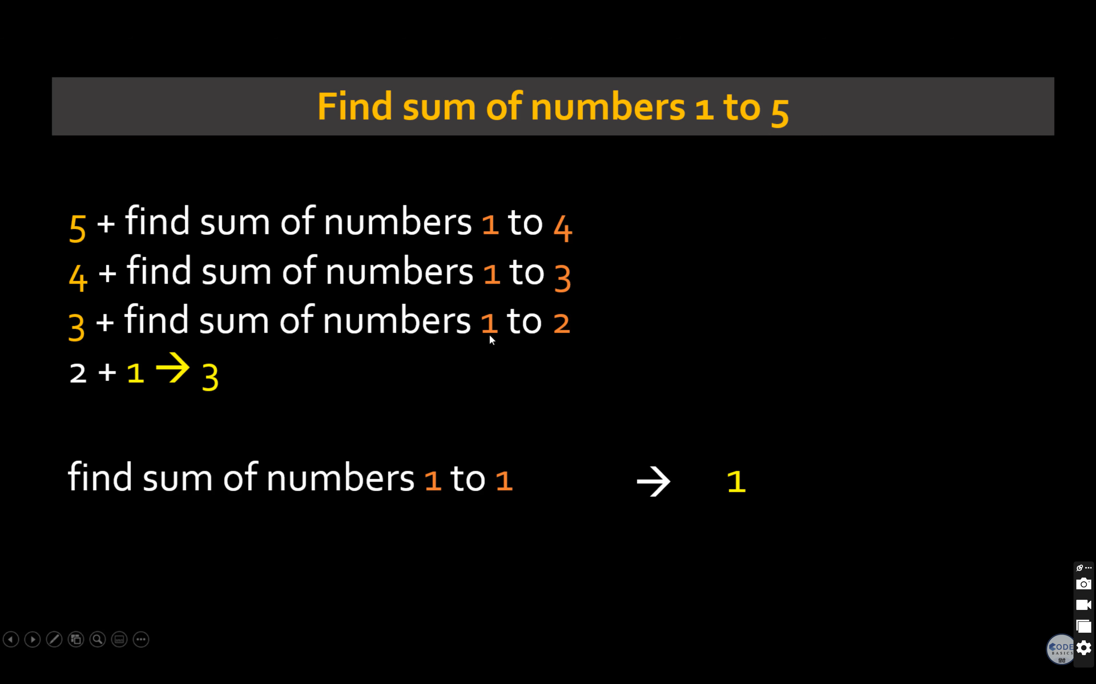

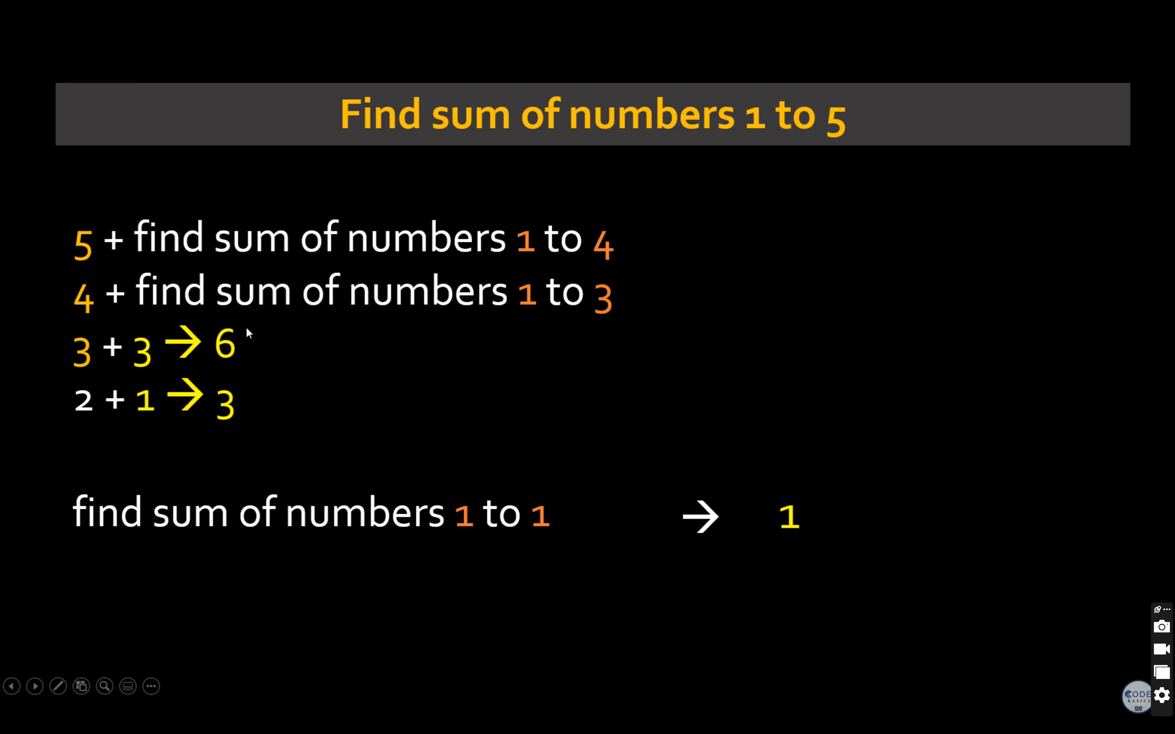

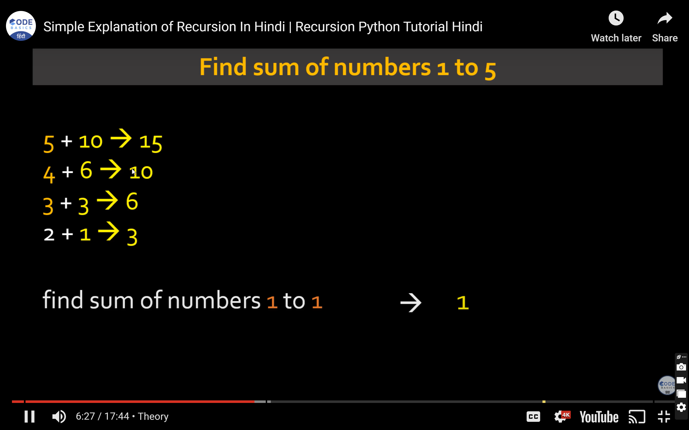

function recurSum(n):

if n <= 1:

return n

return n + recurSum(n - 1)

end function

input n

sum = recrSum(10)

print sum

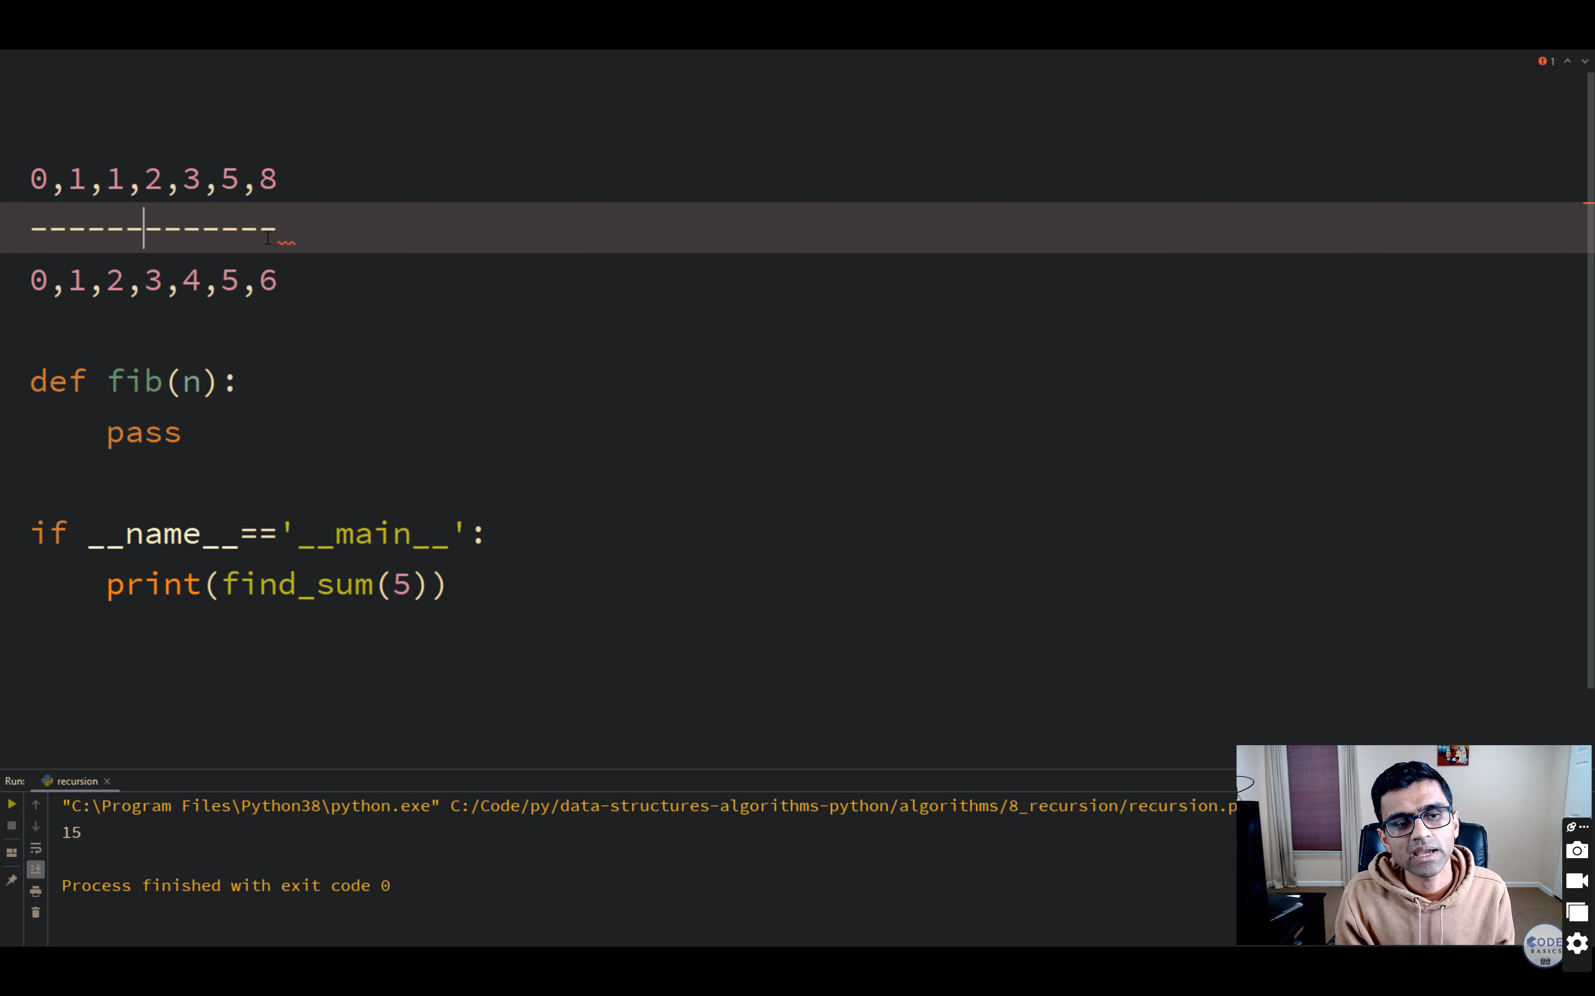

Fibo Series

Fibo(n)

Begin

if n <= 1 then

Return n;

else

Return Call Fibo(n-1) + Call Fibo(n-2);

endif

End

Non recursive

int nonRecFibo(int n){

int i, a, b, f;

if(n <= 1)

return n;

else{

a = 0, b = 1, f = 0;

for(i = 2; i <= n; i++){

f = a + b;

a = b;

b = f;

}

}

return f;

Binary Search

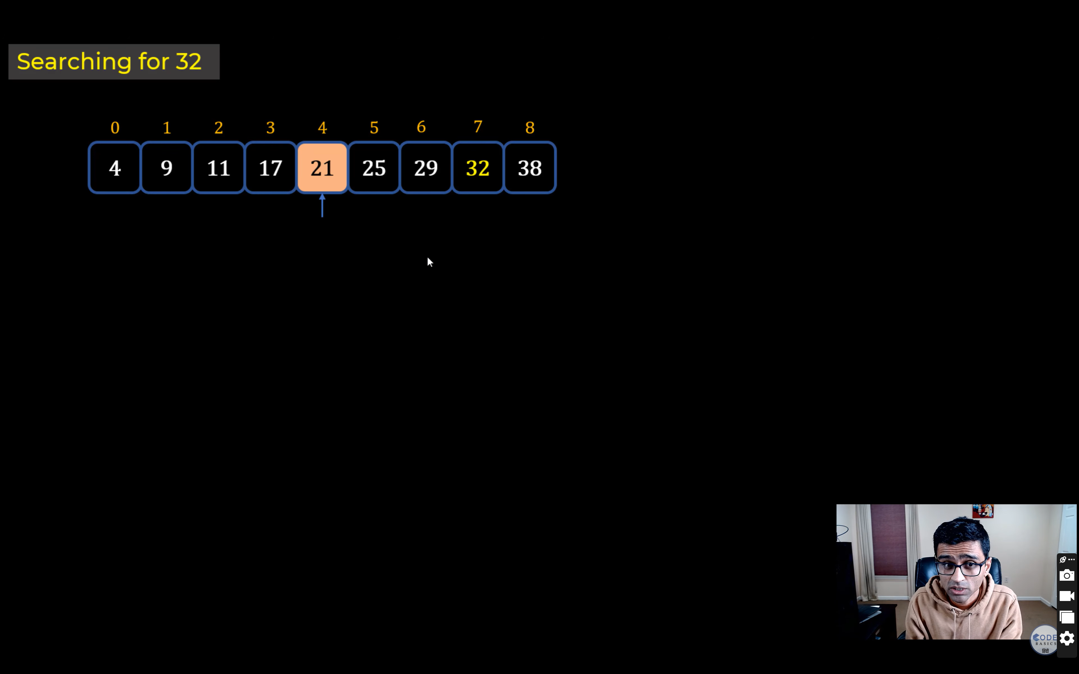

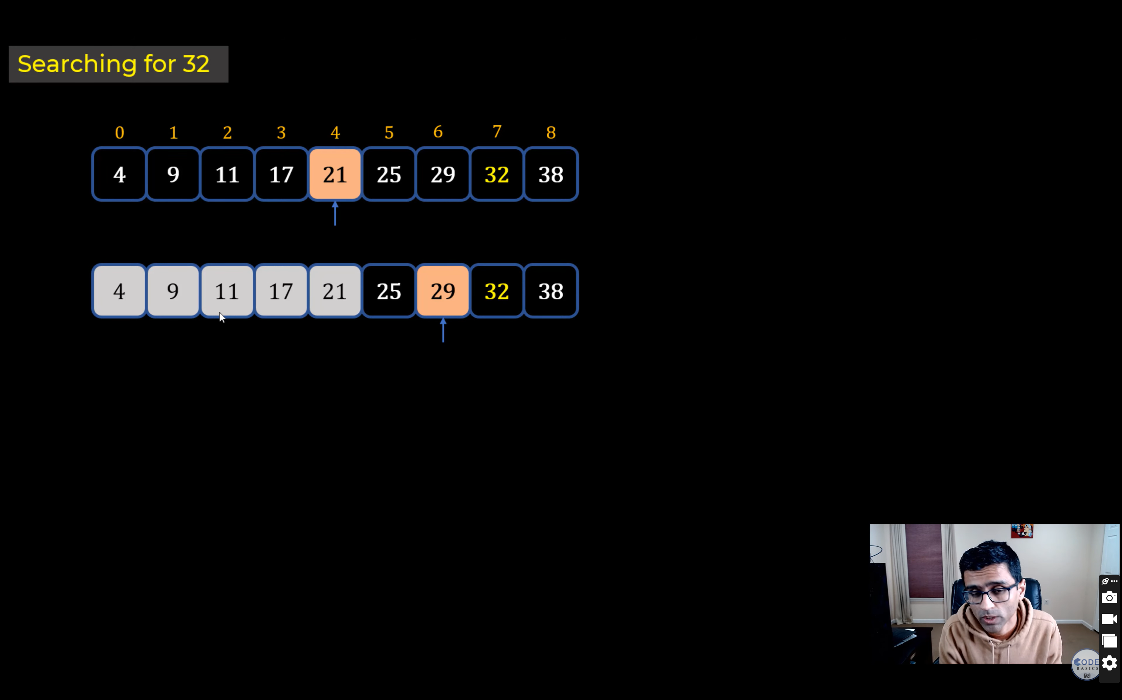

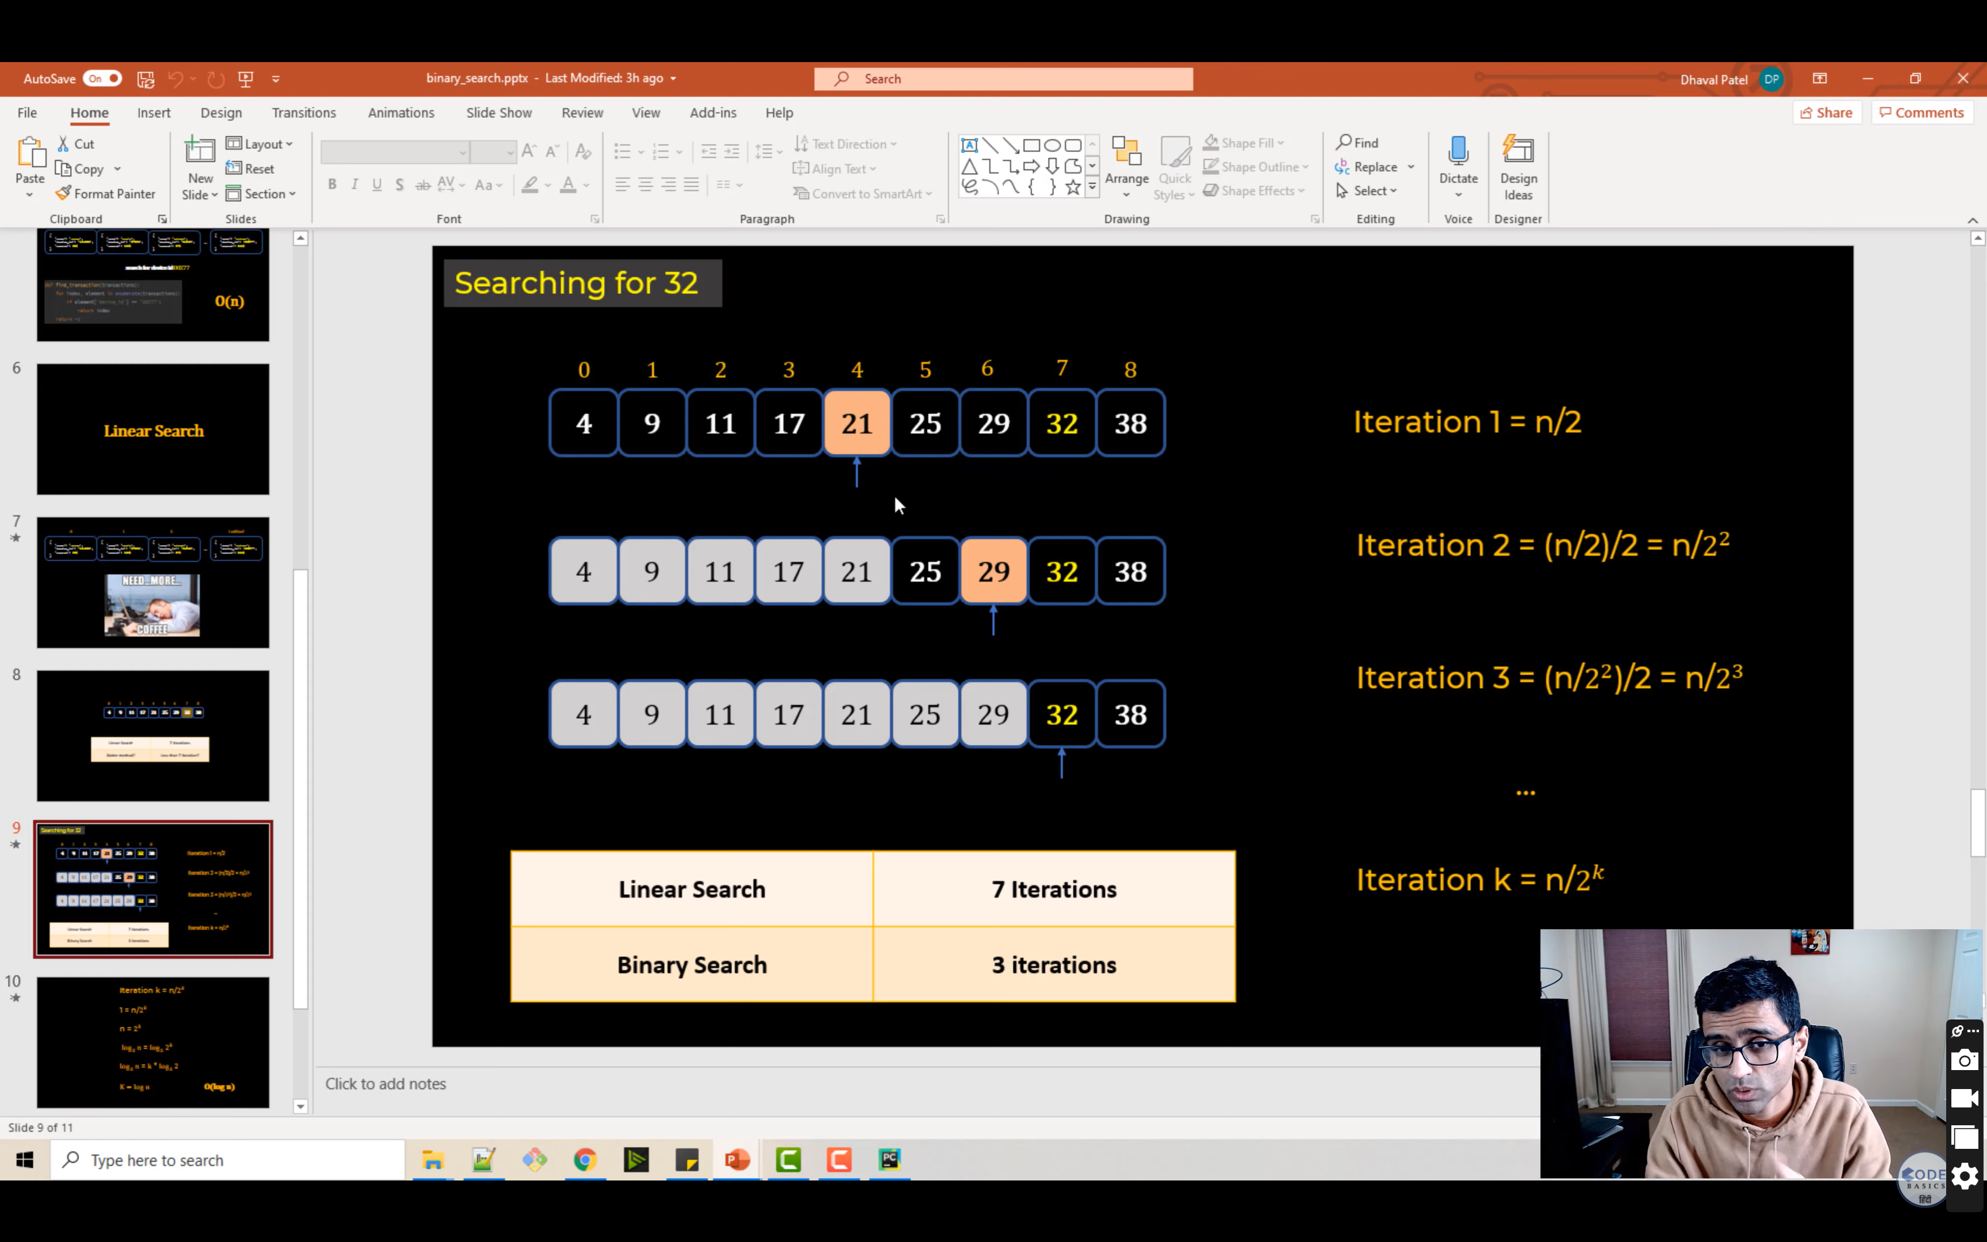

<https://medium.com/@williambdale/recursion-the-pros-and-cons-76d32d75973a>

<https://www.techiedelight.com/binary-search/>